You Are the Miracle Walking in Faith
May 8, 2017
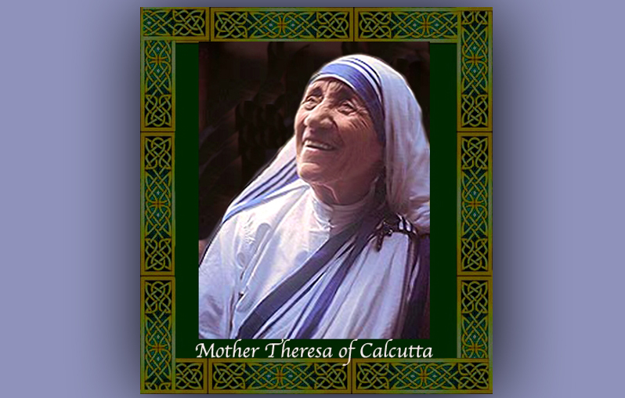
May the Lord Jesus give all of us Heartdwellers the courage we need to step into our destinies, fully expecting Him to provide. Amen

Well, dear friends, last night I had a breakthrough with music, a real sense of flowing in the Spirit. Obstacles were overcome, fears were overcome as I just plain obeyed and set to work following my inspirations. That is, after binding the enemy and praying for grace and favor with God.

The Lord began, “Expect Me to act. When you step out in hope - especially when your faith is being tried - but you hold firmly to the rope of grace that I am faithful, expect Me to act.

“Many of you are not moving forward as I would like you to, because you are waiting for a miracle. May I say, your miracle is in you moving forward despite all the odds. You most glorify Me when your faith is flagging, yet you hold fast to it and step forward anyway.

“Clare had a breakthrough last night for that very same reason. She expected Me to act, although she didn’t know the particulars. All she knew was that I had promised her, through several people, that the anointing was coming. So, hoping against hope she lunged forward right into the arms of her destiny as I revealed a new gift manifesting through her faithfulness.

“My children, you are the miracle when you lunge forward in faith. When you sit there waiting for Me to act, you are not an inspiration to anyone. Did you know, that at the very least, you as a Christian are to encourage others to keep going by your decisive actions in moving into your destinies?

“Her knees were knocking together as she began the portrait, after she made the bold claim that I would do it through her and it would be anointed. I want you to see My eyes, the love in My eyes, the expression of My mouth and face - that I am smitten in the presence of My Bride. How are you to understand this without some kind of image to behold? Yes, the secret of My longing and loving you is tied up in the expression of My face - so open, so in love and so inviting. But what if she had sat there and said, ‘Well, I’d better try and take an art class before I do this.”

“What kind of faith would that be? Do I not know more about creating than any of those I created on this Earth? So, shall I not faithfully depict My loving expression through this vessel who has no talent on her own? Yes, this is why I chose her…no talent, very little experience, certainly not like the forensic artist she so admires the work of.

“But do you know that in order for you to create a piece that is convincing of My Love for you, you must be living, dwelling, breathing and acting from My Heart. You must know Me intimately in order to portray My Love for each and every one of you. She had no talent - but lots of love and familiarity with Me. That’s why I chose her to do this portrait.

“Now, must I remind you that I’ve found you dwelling in My Heart and that’s what qualifies you for an assignment that will bring My Bride closer into My very arms? Age is no impediment. Sickness is no impediment. Inexperience is no impediment - none of these things the world turns on qualify anyone to undertake a work for Me. Only love and an intimate knowledge of Me does that.

“Mother Theresa had this love and knowledge of Me, along with administration for years as a teacher to the rich. When she heard My call to the poorest of the poor, she had no funding, no building, no medicines, no food, no salary. She had nothing but a heart full of love for Me, faith and obedience. This is what accomplished the impossible, as she was persecuted every step of the way in providing for the poor.

“I did miracle, after miracle, after miracle for her because of her faith that I would do the doing through her. She didn’t wait for funding. She didn’t wait for workers to join her. She stepped out of the safe and ample provision of the convent into the hostile environment of the streets of Calcutta, filled with disease, thieves, Muslims, Hindus - fully armed with scorn ad contempt for this Christian woman.

“This is what I am asking of you, My sluggish ones. You are thickening on your lees, waiting for someone to come along and live your faith for you. No, no! I have given you the mandate to move forward and no one is going to drop out of the sky with a tidy little package of steps and provision in their hands.

“You will find the directions and provisions each morning when you come to Me in worship, adoration and prayer. You will walk into your prayer naked and blind, and walk out fully clothed in My grace. Informed, with eyes wide open to the possibilities that lie ahead.

“I am calling you to break out of your mold of complacency. Some of you have been dragging your feet because the Rapture is happening tomorrow - or so you are told. And how many tomorrows have anxiously passed by, with no results at all? Some of you are holding your breath because you’ve been led to believe the first nuke is coming from North Korea any time now. How much time have you wasted waiting?

“Besides that, how do you know that I’m not calling you into a place for a future event? You have no way of knowing that. You’re just watching all the wrong sources of information and waiting for what they say will happen to happen. Do you know that some of these people are making thousands of dollars a week keeping you on the edge of your seats.? You indeed are being used. Your weakness is fear and so you must get the latest fix on what could happen to you tomorrow - rather than throwing that caution to the wind and stepping forward to change something for the better in the world, while there is yet time.

“Forgive Me for being a bit harsh with you, My chosen ones. But I am waiting…I am disappointed that you have not acted on My promises to you yet. I want you in the position to be able to receive the release of graces from Heaven that has only begun to trickle down on the faithful ones who are stepping out with nothing.

“I have much for you, but you will miss it if you don’t get going now into your calling. You know what I have put in your heart…now act on it. Stop procrastinating. Walk into your destiny, hand in hand with Me. I will place you beneath the glory spout and you will indeed be empowered. But that will not be the miracle others will see. No the miracle will be you stepping out in faith with nothing. That is what will convince them that I am real, when they see Me providing for you and bringing you deeper and deeper into your ever-expanding destinies.

“Come now. I have reasoned with you. Come now…let us take the first steps together. Courage! I will not leave you or abandon you to the will of your enemies. Rather, I will cover and protect you and you will declare the faithfulness of your God to the nations.”

